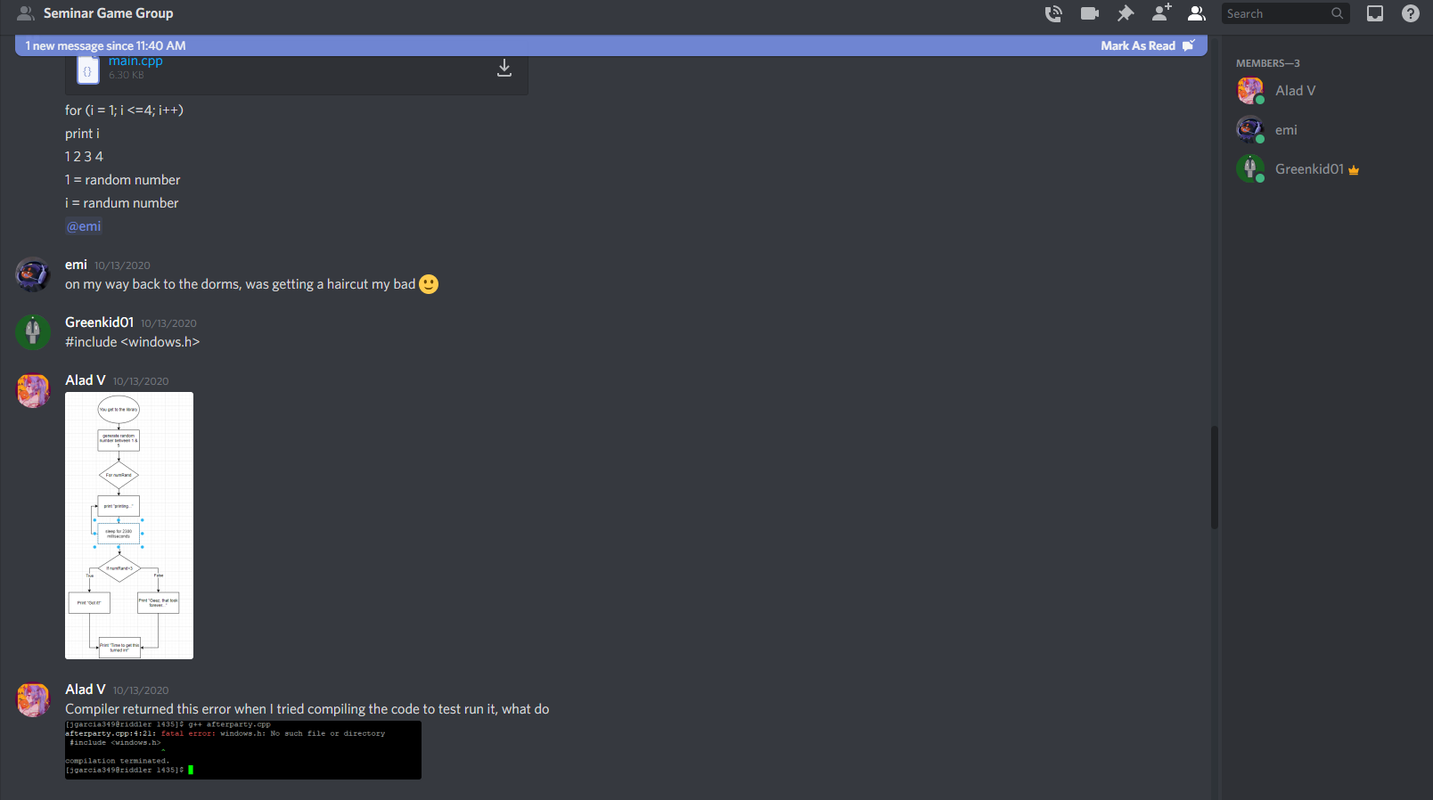

This week me and my Seminar Game Group got together to talk about our game, more in-depth ideas about it and how we will put it all together. This was a nice time to really put into prosses what we want the final product to be, as well as how we will get there and the steps we need to take. We all gave our own ideas that we want introduced into the game.